**Chapter 4 Programming Challenges (45 points)**

In Chapter 4, we discussed the following topics:

* Relational Operators
* The *if* statement
* Expanding the *if* statement
* The *if/else* statement
* Nested *if*
* The *if/else* statement
* Flags
* Logical Operators

These techniques allow us to ask for input from the user, make calculations using various data types, and display that output in a user-friendly format. This lab asks you to write three programs which implement some of these topics. When developing your programs, please remember to add your header information. Use comments to self-document your code and be mindful of the spelling and formatting of your data, both *input* and *output*. Use different decision structures throughout your code.

**Program 1**

**Time Calculator**

Write a program that asks the user to enter a number of seconds. Print out all the minutes, hours, and days that may be represented by the input value.

* There are 60 seconds in a minute. If the number of seconds entered by the user is greater than or equal to 60, the program should display the number of minutes in that many seconds.
* There are 3,600 seconds in an hour. If the number of seconds entered by the user is greater than or equal to 3,600, the program should display the number of hours in that many seconds as well as the number of minutes.
* There are 86,400 seconds in a day. If the number of seconds entered by the user is greater than or equal to 86,400, the program should display the number of days, hours, and minutes in that many seconds.

**For example:**

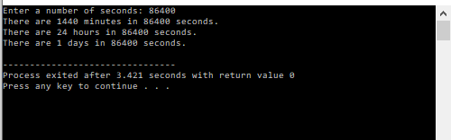

**Program 2**

**Color Mixer**

The colors red, blue, and yellow are known as primary colors because they cannot be made by mixing other colors. When you mix two primary colors, you get a secondary color, as shown here:

* When you mix red and blue, you get purple.
* When you mix red and yellow, you get orange.
* When you mix blue and yellow, you get green.

Write a program that prompts the user to enter the names of two primary colors to mix. If the user enters anything other than “red,” “blue,” or “yellow,” the program should display an error message. Otherwise, the program should display the name of the secondary color that results by mixing two primary colors. Decide what happens if you enter two primary color choices that are the same.

**For example:**

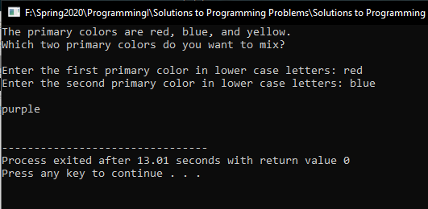

**Program 3**

**Math Tutor**

Write a program that can be used as a math tutor for a young student. The program should first ask the student what arithmetic operation they want to perform (choose among addition, subtraction, multiplication, or division). Then ask the user for two numbers (the operands). Then the program asks the student for the answer.

The program should wait for the student to enter the answer. If the answer is correct, a message of congratulations should be printed. If the answer is incorrect, a message should be printed showing the correct answer.